texto = "With Colab you can import an image dataset, train an image classifier on it, and evaluate the model, all in just a few lines of code. Colab notebooks execute code on Google's cloud servers, meaning you can leverage the power of Google hardware, including GPUs and TPUs, regardless of the power of your machine. All you need is a browser."

#incluya ‘ ‘
import re
texto = re.sub(r"[^a-zA-Z0-9 ]","", texto)

texto = texto.replace("!","").replace(",","").replace(".","").lower().split(" ")

arreglo = texto.split(sep=" ")
arreglo

OUTPUT

['With',
'Colab',
'you',
'can',
'import',
'an',

def riqueza_lexica(texto):

#lista de palabras diferentes
vocabulario = sorted(set(texto))
return len(vocabulario)/len(texto)

x = riqueza_lexica(arreglo)
print(x)

OUTPUT

0.733

lista={}
for palabra in set(arreglo):
lista[palabra] = arreglo.count(palabra)

import matplotlib.pyplot as plt
from nltk.probability import FreqDist

fdist = FreqDist(arreglo)
fdist.most_common(10)
fdist.plot(10)

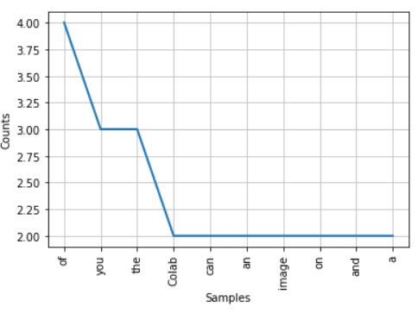

lista['you']

OUTPUT

3

arreglo[0]

With

Sorted by Word

sorted(lista)

from sortedcontainers import SortedDict
SortedDict(lista)

Sorted by number of times

sorted(lista.items(), key=lambda x: x[1], reverse=True)

[('of', 4),
('you', 3),
('the', 3),
('a', 2),
('image', 2),
('and', 2),
('Colab', 2),
('an', 2),
('can', 2),
('power', 2),
('on', 2),
('code', 2),
('Googles', 1),
('hardware', 1),
('is', 1),

